Behavioral Segmentation for Targeted Marketing

Project Id: AIML-10

Name : Aditya Duuta
Class Roll Number:29
University Roll Number : 2028623
Section and Group: U(G1)

Name : Akash Kumar
Class Roll Number:30
University Roll Number : 2028629
Section and Group: U(G1)

Name : Himanshu Kumar
Class Roll Number : 14
University Roll Number:2028428
Section and Group: U(G1)

TABLE OF CONTENTS
- Problem Description 3
  - Dataset Description 3
  - Flow diagram 4
- Modules for Project Implementation…………………..…………………………5
  - Modules Used 5
  - Platform Used 6
- Machine Learning model/ Searching Technique used 7
- Evaluation metrics used 8
- Results and Visualizations 9
- Conclusion and Future Scope 11
- References 12

- Problem Description
In today’s market, businesses need to understand their customers better to offer the right products and services. This project focuses on grouping customers based on their buying behavior using a machine learning technique called K-Means clustering. The aim is to identify different types of customers, also known as customer segments or personas. Before applying the algorithm, the data is scaled using Standard Scaler so that all features are treated equally and no single value dominates the results. The Elbow Method is then used to find the most suitable number of clusters for accurate segmentation. By dividing customers into meaningful groups, businesses can create more targeted marketing strategies, improve customer experience, and increase overall sales. This type of analysis is commonly used in real-life scenarios such as online shopping platforms, retail businesses, and digital marketing systems, where understanding customer behavior plays a key role in decision-making.
  - Dataset Description
The dataset contains 1000 rows with 9 columns that represent-
1.Customer id
2.Annual Income
3.Purchase Frequency
4.Annual Spending
5.Age
6.Spending Score
7.Gender
8.Region
9.income Level

1.2 Flow Diagram

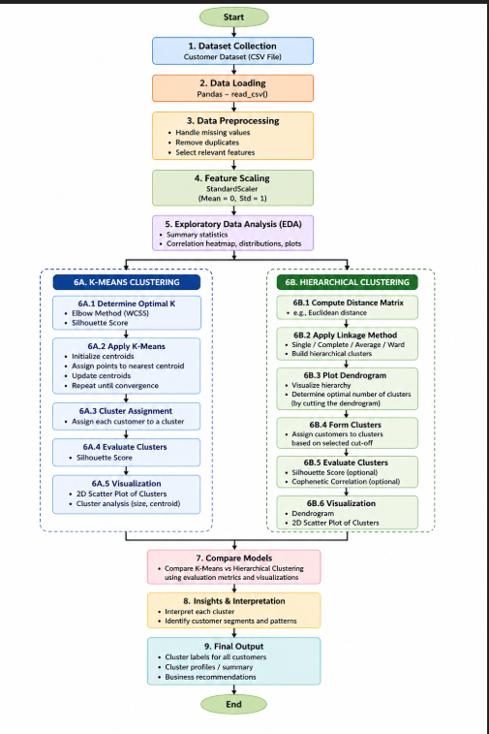
Fig.1 flow diagram.

2. Modules for Project Implementation

2.1 Modules Used (mention all the inbuilt/ custom modules used and the purpose)

1.Pandas

Pandas module has been used for data manipulation and analysis.
Functions used:
pd.read_csv- to read data from csv file in a pandas dataframe.

2.Numpy
- Used for numerical computations
- Helps in handling arrays and mathematical operations
3. Matplotlib
- Used for basic data visualization
- Plotting Elbow graph
- Scatter plots for clusters

4. Seaborn
- Advanced visualization library built on Matplotlib
- Heatmaps
- Distribution plots
- Better-looking cluster visualizations

5. Scikit-learn (sklearn)

This is the main machine learning library used in your project.
Submodules used:
a) sklearn.preprocessing
- StandardScaler
Used for feature scaling

b) sklearn.cluster
- KMeans
Used for K-Means clustering
- AgglomerativeClustering
Used for Hierarchical clustering

c) sklearn.metrics
- silhouette_score
Used to evaluate clustering quality

2.2 Platform Used:

  - Visual Studio Code: For code writing, testing, and debugging.
VS Code is equipped with multiple extensions, debugger which enhance the development experience.
  - Jupyter: For code writing, testing and debugging. It is easy to use and has all important sklearn libraries for machine learning

3. Machine Learning Model/ Searching Technique Used-

This project uses unsupervised machine learning models to perform customer segmentation. Unlike supervised learning, these models do not require labeled data and instead identify hidden patterns and group similar data points.

1. K-Means Clustering
Introduction
K-Means is a centroid-based clustering algorithm that partitions the dataset into K distinct clusters. Each cluster is represented by a centroid (mean point), and data points are assigned to the nearest centroid.

Working Algorithm
- Choose the number of clusters (K)
- Initialize K centroids randomly
- Assign each data point to the nearest centroid (using distance metric like Euclidean distance)
- Recalculate centroids as the mean of assigned points

2. Hierarchical Clustering
Introduction
Hierarchical Clustering builds a tree-like structure (called a dendrogram) to represent nested clusters. It does not require pre-specifying the number of clusters.

Working Algorithm (Agglomerative)
- Treat each data point as a separate cluster
- Compute distance between all clusters
- Merge the two closest clusters
- Repeat until all points form a single cluster

4. Evaluation metrics used (Describe each evaluation metric used along with formulae)

Silhouette Score
Definition
Silhouette Score measures how well a data point fits within its cluster compared to other clusters.
Formula
Where:
- a = average distance to points in the same cluster
- b = average distance to points in nearest cluster
🔹 Range
- +1 → well clustered
- 0 → overlapping clusters
- -1 → wrong clustering
🔹 Interpretation
- Higher score → better cluster separation

5. Results and Visualizations

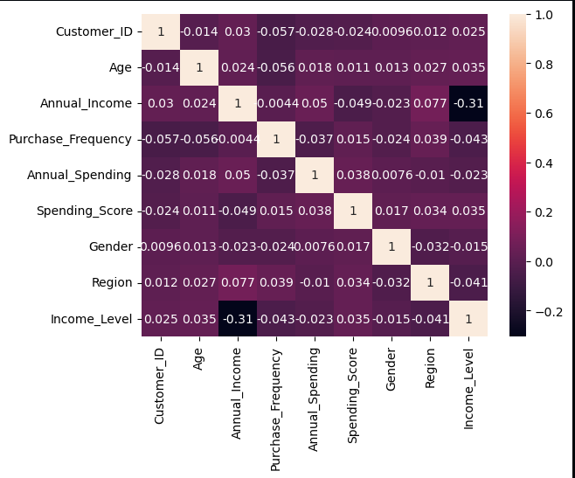

Fig.2 Heatmap showing corelation.

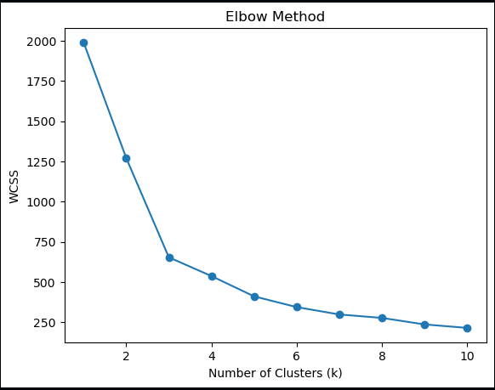
Fig.3 elbow method to find k

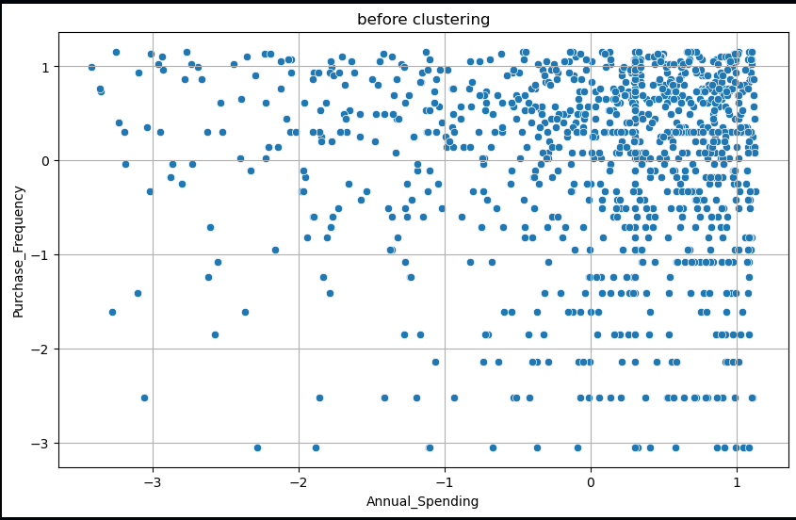
Fig.4 before clustering

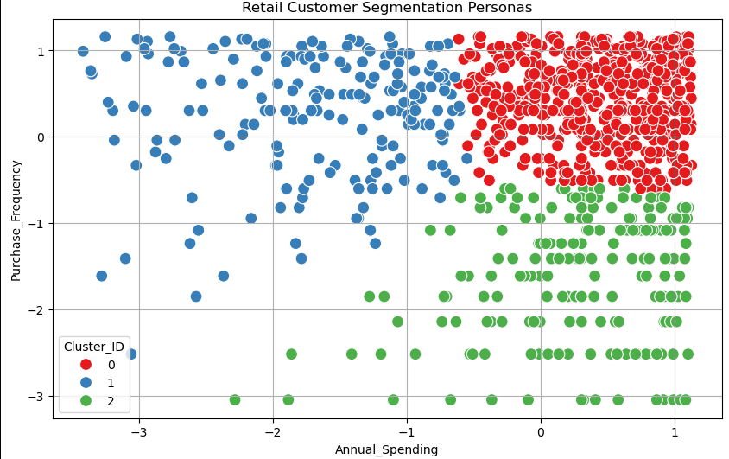
Fig 5- after clustering using kmeans

Fig 6- silhouette score for kmeans

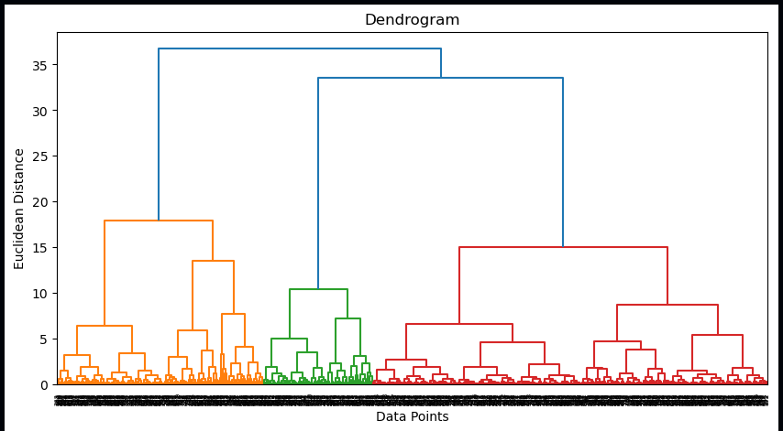
Fig 7- dendrogram to find k

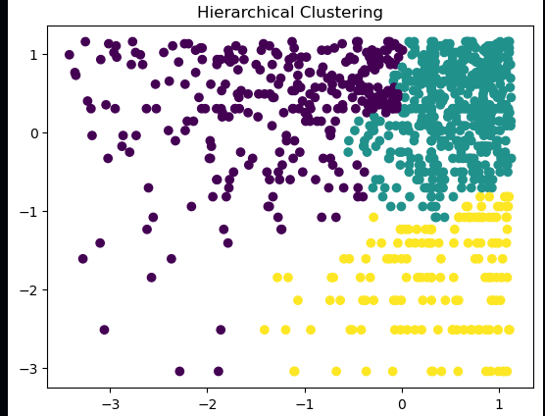
Fig 8- clustering using hierarchical clustering

Fig 9- hierarchical clustering silhouette score

6. Conclusion and Future Scope:
Conclusion
In this project, a Customer Segmentation System was successfully developed using unsupervised machine learning techniques, primarily K-Means Clustering and Hierarchical Clustering. The objective was to group customers based on similarities in their attributes such as income, spending behavior, and other relevant features.
The dataset was first preprocessed by handling missing values, removing duplicates, and applying feature scaling using StandardScaler to ensure uniform contribution of all features. Exploratory Data Analysis (EDA) helped in understanding the structure and relationships within the data.
K-Means clustering was implemented by determining the optimal number of clusters using the Elbow Method and validating the results with the Silhouette Score. In parallel, Hierarchical Clustering was applied using linkage methods and dendrogram visualization to identify natural groupings in the dataset.
The results showed that customers can be effectively segmented into distinct groups such as high-value customers, low-value customers, and potential target customers. These clusters provide meaningful insights that can help businesses design targeted marketing strategies, improve customer engagement, and optimize resource allocation.
Overall, the project demonstrates that clustering techniques are powerful tools for uncovering hidden patterns in data and supporting data-driven decision-making.

🔹 Future Scope / Future Use
Although the current system performs effective segmentation, there are several ways it can be improved and extended:
🔸 1. Use of Advanced Clustering Algorithms
- Implement algorithms like:
  - DBSCAN (density-based clustering)
  - Gaussian Mixture Models (GMM)
- These can handle complex and non-spherical clusters better than K-Means

🔸 2. Real-Time Customer Segmentation
- Integrate the model with live data systems
- Allow businesses to segment customers dynamically as new data arrives

🔸 3. Integration with Recommendation Systems
- Combine clustering with recommendation engines
- Suggest products/services based on customer segment

🔸 4. Use of More Features
- Include:
  - Purchase history
  - Browsing behavior
  - Customer demographics
- This will improve segmentation accuracy

🔸 5. Deployment as a Web Application
- Build a user interface using:
  - Flask / Django
- Allow non-technical users to upload data and view results

🔸 6. Visualization Dashboards
- Use tools like:
  - Power BI / Tableau
- Create interactive dashboards for business users

🔸 7. Automated Model Selection
- Automatically compare multiple clustering techniques
- Select the best one based on evaluation metrics

7. References:
Books:
- Let Us Python – Yashavant Kanetkar

Online Resources:
  - GeeksforGeeks – https://www.geeksforgeeks.org/
  - TutorialsPoint – https://www.tutorialspoint.com/cprogramming/index.htm
  - Stack Overflow – https://stackoverflow.com

